This problem will be worth 14 points. There is the one student tester and 10 additional tests for a total of 11 tests. Additional bonus points will be awarded for correctly implementing methods 1-4, methods 5-7, methods 8-9 and a final bonus point for correctly implementing all 10 methods in this class.

This problem will ask you to implement the following functions. One function is defined recursively. Other times I will give you functions from the java.lang.Math with a brief description, and some times you just need to implement the function. In all the following functions you do NOT need worry about domain issues. That is, you may assume that all test data will not cause any exceptions to be thrown. In total, there are ten different functions in this problem. Each successfully implemented function will earn you a point. Complete all 10 and you will earn a bonus (twelfth) point from this problem. Except for the first method and all Boolean methods, all methods will return a double. Your method must return value within 0.05 of the correct answer to be considered correct.

You should use:
- Math.abs(x) for |x|
- Math.sqrt(x) for 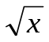
- Math.pow(x, 1.0/n) for 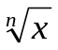
- Math.log(a) for 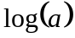
- Math.log10(a) for 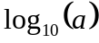
- Math.cos(a) for cos(a)
- Math.sin(a) for sin(a)
- Math.tan(a) for tan(a)

- Implement the following recursive function.
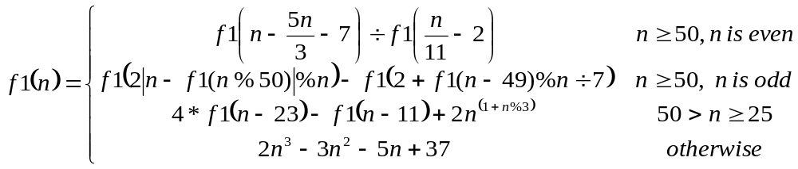
using the following function heading:
public static int f1(int n)

Test data: f1(60) returns -4367
The test data has been hand validated
f1(61) returns -6820
f1(25) returns -3493
f1(12) returns 3001

The correct call to a recursive static method is of the form: FunctionsGoneWildPartIII.f1(n)

- Implement the following function.
Consider the mathematical notation 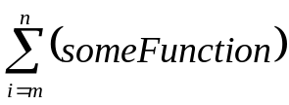 used to represent the summation of many similar terms. The notation 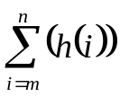 is defined as:
The subscript gives the symbol for an index variable, i. Here, i represents the index of summation; m is the lower bound of summation, and n is the upper bound of summation. Here i = m under the summation symbol means that the index i starts out equal to m. Successive values of i are found by adding 1 to the previous value of i, stopping when i = n. An example:
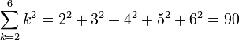.

Your task in this problem is to implement the following function.
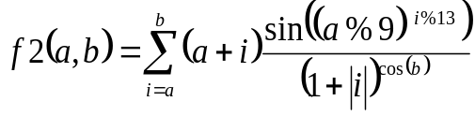 =
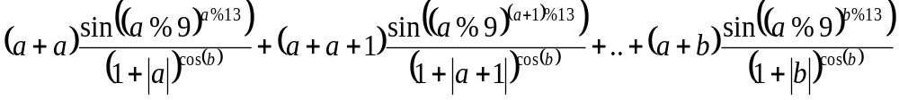
using the following function heading:
public static double f2(int a, int b)

Test data: f2(1, 4) returns 28.20085

- Implement the following function.
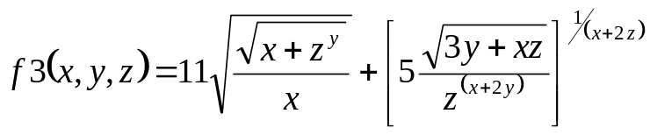
Use the following function heading:
public static double f3(double x, double y, double z)

Test data: f3(50, 2, 1) returns 5.2293327

4. Implement the following function
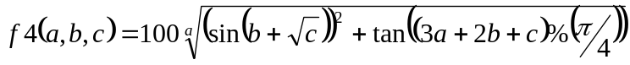,
Use following function heading:
public static double f4(double a, double b, double c)

Test data: f4(6, 4, 2)) returns 102.2666

* Since this function contains ‘100*’, you only need to be with 0.25.

5. Implement the following function
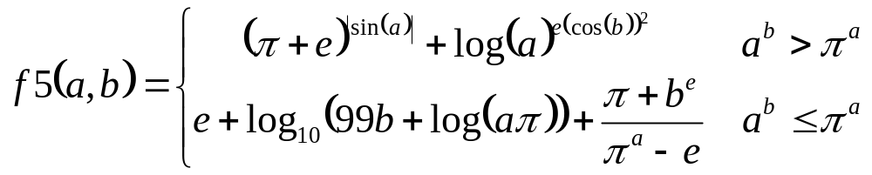
Use the following constant for both pi (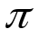) and 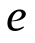
Math.PI | The double value that is closer than any other to pi, the ratio of the circumference of a circle to its diameter.
Math.E | The double value that is closer than any other to e, the base of the natural logarithms.
Use following function heading:
public static double f5(double a, double b)

Test data: f5(5, 5) returns 6.55907
f5(1, 5) returns 200.4808

6. Implement the following function
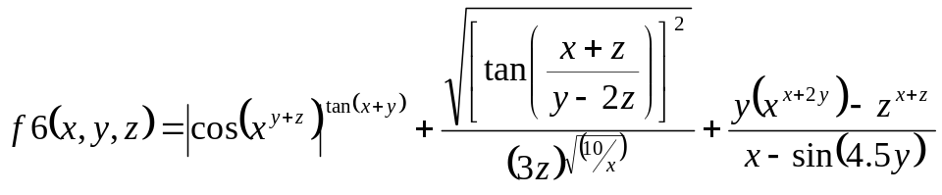
Note – yes, the denominator in the middle term is (3z) raised the square root of (10/x).

Use following function heading:
public static double f6(double x, double y, double z)

Test data: f6(1, 2, 3) returns -133.28760

- Implement the following function
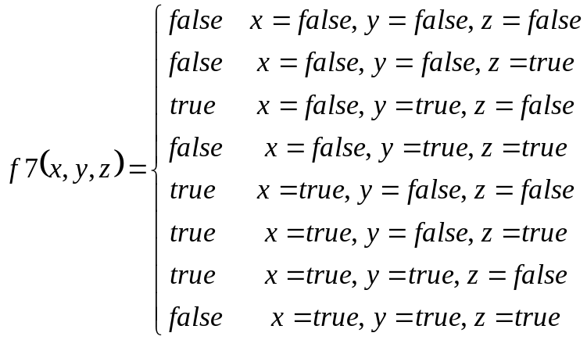
Use following function heading:
public static boolean f7(boolean x, boolean y, boolean z)

Test data: f7(false, true, false) returns true

- Implement the following function
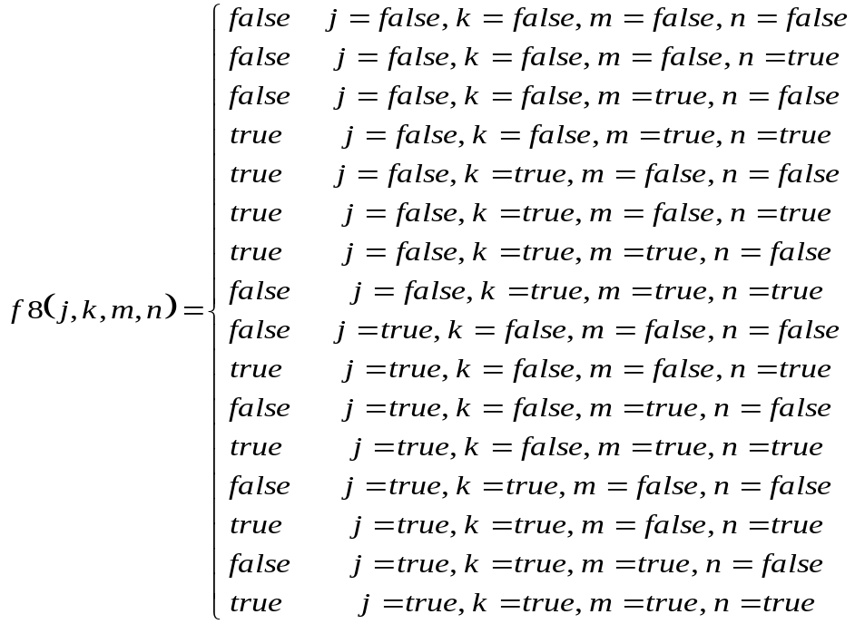
Use following function heading:
public static boolean f8(boolean j, boolean k, boolean m, boolean n)

Test data: f8(false, true, false, true) returns true

- Implement the following function
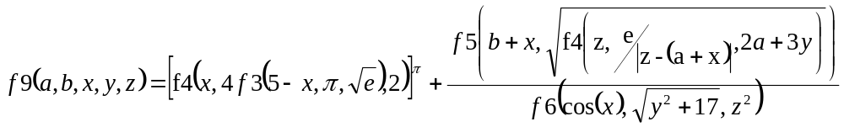
Use following function heading:

Recall Math.PI and Math.E are constant that should be used as for the values π and e.

public static double f9(double a, double b,
double x, double y, double z)

Test data: f9(8.7, 4.9, 4.8, 3.1, 24.3) returns 2395425.206

- Implement the following function
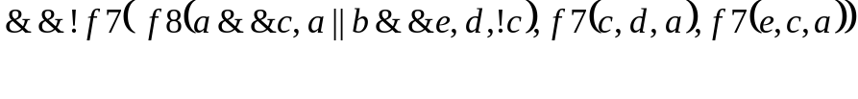
Use following function heading:
public static boolean f10(boolean a, boolean b, boolean c,
boolean d, boolean d)

Test data: f10(false, false, true, false, true) returns true

Each of the above functions is tested individually. Each function that is correctly implemented will earn one point. Additional bonus point for correctly implementing all groups of functions correctly as described in the first paragraph will be awarded! A total of 15 points are available.

